Riddle Me This!

This activity is good for upper elementary – High School

Teacher Notes:
Students can solve a riddle using location-based treasure hunting, which uses adventure of geocaching as a teaching tool.
First step is creating a riddle that needs to be pieced together to get a final answer.

Questions can cover any topic, any subject. This particular example is a math riddle.
The riddle is:

Math: A barrel of water weighs 20 pounds. What must you add to it to make it weigh 12 pounds? (Holes)
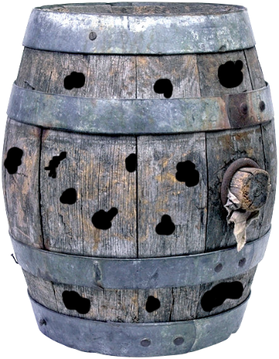
Step One: Get a picture of a barrel with holes and create a puzzle from it. The more groups you have, the more barrels you will need to cut out. If you have 4 groups, you will need 4 pictures of the same barrel.

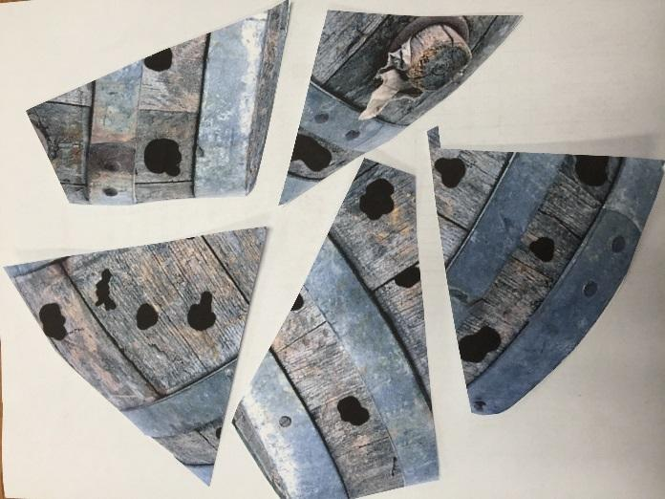
Step Two: Cut the pictures into several pieces. (Don’t mix up the puzzle pieces!)
The number of pieces you create depends on how many caches you want students to find. This is cut into 5 pieces so I will have 5 cache boxes. If you are doing 4 groups you will have 4 of the same piece (#1) in a box.

Step Three: Put a number on the back of each piece and make sure you let the students know how many pieces they will be collecting.
- Place the same numbered piece in each box. Remember, you will have 5 boxes. If you have 4 (or 5) groups, there will be 4 puzzle pieces in each box.
Example:
Box 1 - 4 puzzle pieces, all with #1 written on the back. Go to coordinate #2
Box 2 - 4 puzzle pieces, all with #2 written on the back. Go to coordinate #3
Box 3 - 4 puzzle pieces, all with #3 written on the back. Go to coordinate #4
Box 4 - 4 puzzle pieces, all with #4 written on the back. Go to coordinate #5
Box 5 - 5 puzzle pieces, all with #5 written on the back. Go to coordinate #1 (unless you are group 1)

- Hide each box, making sure they are at least 500 ft. apart from each other.
- As you hide them, mark each spot with a waypoint. (Write down the coordinates to make sure you have them in case they get accidentally deleted from your device.
- Time to make your Clue Sheet. It should look something like this

There are 5 cache boxes hidden on our school grounds. Each one contains 4 puzzle pieces. It’s up to you to find each one using the coordinates.
A barrel of water weighs 20 pounds. What must you add to it to make it weigh 12 pounds?
Group 1 – Start at coordinate 1 (give waypoint – coordinate)

Group 2 – Start at coordinate 3 (give waypoint – coordinate)

Group 3 – Start at coordinate 4 (give waypoint – coordinate)

Group 4 – Start at coordinate 5 (give waypoint – coordinate)

Once you have collected all of your pieces, put the puzzle together and you will get your answer. Your art teacher can have students recreate the picture using different mediums!
Good luck!

