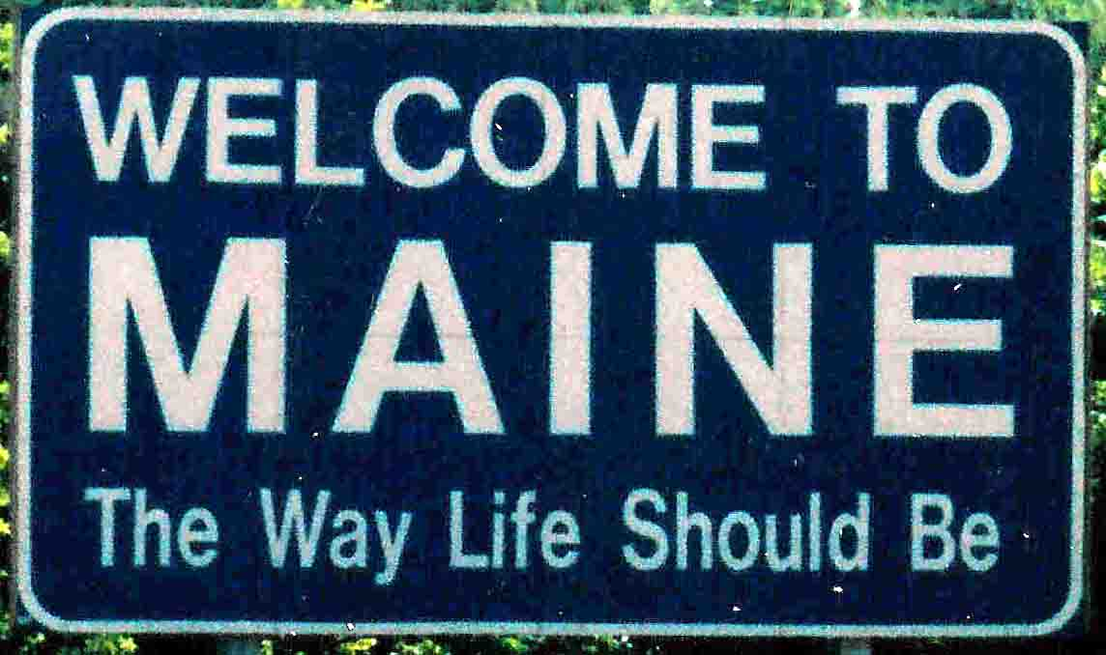

Creating a Travel Guide

5th – 8th grade

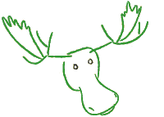

By Cheryl Phillips

Prince William County Schools

Planning My Trip to Maine – Moose Country

Introduction

    I have finally decided to take a trip to Maine to see the moose up close and personal.  I, however, have no clue what it costs to go there let alone, where to stay or what to do. So, I’m asking you to research a few things for me, you know make all my travel plans that would include a detailed itinerary along with the bill.  Remember to make sure that my budget reflects the cost for both Richard (my hubby) and me. Can you do this in under $2,500?

**The Task**

|  |  |
| --- | --- |
| 1. | http://images.animationfactory.com/imagedir/animations/animals/moose/moose_skiing/moose_skiing_lg_nwm.gif Explore Maine and decide which cities I should visit base on the all mighty moose tours. |
| 2. | After choosing the right place to see moose, find out when the best time of year to go there is. |
| 3. | http://images.animationfactory.com/imagedir/animations/nature/weather/sunny_cloud_sunglasses/sunny_cloud_sunglasses_lg_nwm.gif Find out the weather conditions in the spring, because I’d rather go in the spring than in the summer. I need to plan my clothing appropriately. |
| 4. | Research hotels or a Bed and Breakfast in the area I will visit to find out prices and services they have to offer. |
| 5. | * http://images.animationfactory.com/imagedir/media/photo_clips/children_baby/train/train_lg_nwm_me.gif Find three modes of transportation to Maine and the cost for each. Car, Train, Plane. I don’t do busses. * http://www.cokertire.com/skin/frontend/default/coker_new/images/Fiat-500/Fiat500.pngCar Information: Look up gas prices from Virginia to Maine, the mileage (how far is it) and how long do you think it will take me to get there if I drive straight to my first city. You’ll have to do the math by figuring miles per hour. Please assume I will go on the average 65 MPH. **Use Google maps to help you with this!** * If my car gets about 34 miles per gallon, how much gas will I use? * If I take a train or plane, I will need a rental car. How much will it cost per day? Look up the plans; you can either rent by day or by mile. Find me the best price! |
| 6. | * http://www.sbac.edu/~tpl/clipart/Animals and Insects/gator airplane 3.jpg Contact at least two airlines and get prices for traveling to my chosen city from the two airports closest to my home, (Dulles and National). * When you are researching the prices, please include **roundtrip fares**, not just a one-way ticket (I do want to come back!) |
| 7. | http://www.enigmagraphics.com/illust/images/lobster.gifI love lobster so in this trip, find me the freshest and best place to eat a Maine Lobster! |
| 8. | In addition to the moose tour, find three special attractions that I would like to visit on my trip. These could be museums, monuments, churches or other points of interest.  Include admission fee and a brief description for each place. |
| 9. | http://213.183.23.58/shared/logo.gifThe plan is to stay at least 4 days and nights. At least one meal a day will be eaten from a ‘nice’ restaurant, one ‘fast food’ and probably breakfast at the hotel. I would like an average cost of meals per day for 2 adults. |
| 10. | Maps, Maps, and Maps….please include a map of my journey.   * I want to know the states I will be traveling through as well as the major Interstates. * What rivers or major bodies of water will I come close to? * What tolls will I have to pay? |

**Resources**  
[Maine’s Tourist Center](http://www.visitmaine.com/home.php) - <http://www.visitmaine.com/home.php>

[Maine’s Kids page](http://www.state.me.us/sos/kids/allabout/allabout.htm): <http://www.state.me.us/sos/kids/allabout/allabout.htm>

[Maine Resource Guide:](http://maineguide.com/) (Great Travel Information) <http://maineguide.com/>

**Airlines:**

[United Airlines](http://www.united.com/)   
[Delta Airlines](http://www.delta.com/)   
[TWA](http://www.twa.com/)   
[American Airlines](http://www.AA.com/)

**Search Engines:**

[Google](http://www.google.com/)  
 [Yahoo](http://www.yahoo.com/)   
 [Excite](http://www.excite.com/)   
[AltaVista](http://www.altavista.com/)

**The Process:**

**You may work in a group, with partner or by yourself.**

I need this information in a nice tidy format that will be easy to read, therefore, you will need to communicate your travel plans in a PowerPoint presentation. Each slide should depict a number from your task list. See sample below.

**Sample PowerPoint Slide**

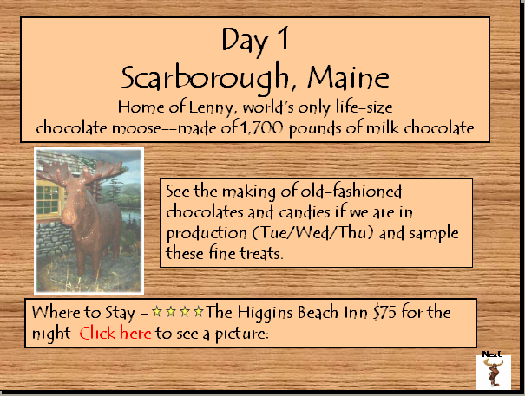

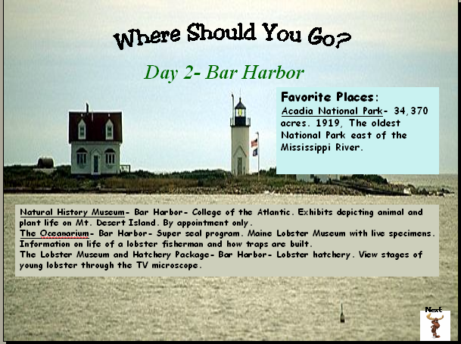



**Criteria: Listed below is the criteria, which will be used to evaluate your PowerPoint presentation. Use this criterion to help you develop a well-written and technologically advanced PowerPoint Slide Show.**

Content:

* Extended information on the itinerary to Maine.
* Grammar and spelling accurate – use of grammar and spellchecker
* Use of storyboard, web, or theme
* Minimum of 10 slides not including title page, but including an introductory and closing slide.
* Don’t forget a slide with the total cost of the trip.

Appearance:

* Easily readable font
* Good page balance of text, graphics, and objects
* Colors complement, do not distract from the presentation
* Background complimentary to text colors and graphics
* Graphics support the theme
* Creativity and artistry

Graphics:

* Appear on more than one slide
* Clip art
* Word art
* Scanned picture
* Digital camera
* Internet source
* Imported element

Multimedia:

* Transition (appropriate for slide)
* Sound from clip gallery or another source (whale songs, or bubbles)
* Hyperlink (optional, but recommended)

Presentation:

* Timing appropriate for presentation type
* Special effects and transitions ADD to presentation and are NON-DISTRACTING
* Logical sequence of slides
* Presentation is not just the actual PowerPoint itself

#### PowerPoint Rubric

Name

**Directions:** The following rubric will be used to evaluate your PowerPoint Presentation. Your teacher will circle the appropriate box, which reflects your mastery level.

|  |  |  |  |  |
| --- | --- | --- | --- | --- |
| **Criteria** | **Needs PowerPoint Help**  (1 point) | **PowerPoint**  **Beginner**  (2 points) | **PowerPoint Literate**  (3 points) | **PowerPoint**  **Pro**  (4 points) |
| Content | Meets two of criteria listed | Meets three of the criteria listed | Meets four or five of the criteria listed | Meets all six criteria listed |
| Appearance | Meets only two criteria listed | Meets only three criteria listed | Meets four or five criteria listed | Meets all six criteria listed |
| **Graphics** | Meets only two criteria listed | Meets four of the criteria listed | Meets five or six of the criteria listed | Meets seven or eight of the criteria listed |
| **Multimedia** | Only one transition | Two transitions and at least one sound effect are present | Three to four transitions and two sounds are present | Five or more transitions or sounds are present and appropriate |
| Presentation | Meets only one criteria listed | Meets two of the criteria listed | Meets three or four of the criteria listed | Meets all five criteria listed |
|  |  |  | TOTAL POINTS:  (out of 20 possible points) |  |

**Additional Comments: ______________________________________________________________________________________**

**Conclusion**

By doing this travel plan, you have become acquainted with Maine and have also learned how to search for sites using search tools. You should now be able to use this knowledge to gain information for other projects and to teach other students how to access information using the Internet. Be sure to follow the PowerPoint Guidelines and rubric.

**Objectives**

**Math:**

# Computation and Estimation

5.3 The student will create and solve problems involving addition, subtraction, multiplication, and division of whole numbers, using paper and pencil, estimation, mental computation, and calculators.

5.4 The student will find the sum, difference, and product of two numbers expressed as decimals through thousandths, using an appropriate method of calculation, including paper and pencil, estimation, mental computation, and calculators.

5.5 The student, given a dividend of four digits or fewer and a divisor of two digits or fewer, will find the quotient and remainder.

5.6 The student, given a dividend expressed as a decimal through thousandths and a single-digit divisor, will find the quotient.

5.7 The student will add and subtract with fractions and mixed numbers, with and without regrouping, and express answers in simplest form. Problems will include like and unlike denominators limited to 12 or less.

5.11 The student will choose an appropriate measuring device and unit of measure to solve problems involving measurement of — part of an inch (1/2, 1/4, and 1/8), inches, feet, yards, miles, millimeters, centimeters, meters, and kilometers;

# Probability and Statistics

5.17

c) create a problem statement involving probability and based on information from a given problem situation. Students will not be required to solve the created problem statement.

# Patterns, Functions, and Algebra

5.20 The student will analyze the structure of numerical and geometric patterns (how they change or grow) and express the relationship, using words, tables, graphs, or a mathematical sentence. Concrete materials and calculators will be used.

5.21 The student will

a) investigate and describe the concept of variable;

b) use a variable expression to represent a given verbal quantitative expression involving one operation ; and

c) write an open sentence to represent a given mathematical relationship, using a variable.

5.22 The student will create a problem situation based on a given open sentence using a single variable.

# Geography

USI.2 The student will use maps, globes, photographs, pictures, and tables to

1. locate the seven continents;
2. locate and describe the location of the geographic regions of North America: Coastal Plain, Appalachian Mountains, Canadian Shield, Interior Lowlands, Great Plains, Rocky Mountains, Basin and Range, and Coastal Range;
3. locate and identify the water features important to the early history of the United States: Great Lakes, Mississippi River, Missouri River, Ohio River, Columbia River, Colorado River, Rio Grande, Atlantic Ocean, Pacific Ocean, and Gulf of Mexico.

### 5th grade Writing

5.8 The student will write for a variety of purposes: to describe, to inform, to entertain, and to explain.

1. Choose planning strategies for various writing purposes.
2. Organize information.
3. Demonstrate awareness of intended audience.
4. Use precise and descriptive vocabulary to create tone and voice.
5. Vary sentence structure.
6. Revise writing for clarity.
7. Use available technology to access information.

**4th grade Writing:**

**4.9** The student will use information resources to research a topic.

* Construct questions about a topic.
* Collect information, using the resources of the media center.
* Evaluate and synthesize information for use in writing.

**Technology/ NETS**

|  |  |
| --- | --- |
| **1.** | **Creativity and Innovation** |
|  | Students demonstrate creative thinking, construct knowledge, and develop innovative products and processes using technology. Students: |
|  | |  |  | | --- | --- | | a. | apply existing knowledge to generate new ideas, products, or processes. | | b. | create original works as a means of personal or group expression. | | c. | use models and simulations to explore complex systems and issues. | | d. | identify trends and forecast possibilities. | |
| **2.** | **Communication and Collaboration** |
|  | Students use digital media and environments to communicate and work collaboratively, including at a distance, to support individual learning and contribute to the learning of others. Students: |
|  | |  |  | | --- | --- | | a. | interact, collaborate, and publish with peers, experts, or others employing a variety of digital environments and media. | | b. | communicate information and ideas effectively to multiple audiences using a variety of media and formats. | | c. | develop cultural understanding and global awareness by engaging with learners of other cultures. | | d. | contribute to project teams to produce original works or solve problems. | |
| **3.** | **Research and Information Fluency** |
|  | Students apply digital tools to gather, evaluate, and use information. Students: |
|  | |  |  | | --- | --- | | a. | plan strategies to guide inquiry. | | b. | locate, organize, analyze, evaluate, synthesize, and ethically use information from a variety of sources and media. | | c. | evaluate and select information sources and digital tools based on the appropriateness to specific tasks. | | d. | process data and report results. | |
| **4.** | **Critical Thinking, Problem Solving, and Decision Making** |
|  | Students use critical thinking skills to plan and conduct research, manage projects, solve problems, and make informed decisions using appropriate digital tools and resources. Students: |
|  | |  |  | | --- | --- | | a. | identify and define authentic problems and significant questions for investigation. | | b. | plan and manage activities to develop a solution or complete a project. | | c. | collect and analyze data to identify solutions and/or make informed decisions. | | d. | use multiple processes and diverse perspectives to explore alternative solutions. | |
| **5.** | **Digital Citizenship** |
|  | Students understand human, cultural, and societal issues related to technology and practice legal and ethical behavior. Students: |
|  | |  |  | | --- | --- | | a. | advocate and practice safe, legal, and responsible use of information and technology. | | b. | exhibit a positive attitude toward using technology that supports collaboration, learning, and productivity. | | c. | demonstrate personal responsibility for lifelong learning. | | d. | exhibit leadership for digital citizenship. | |
| **6.** | **Technology Operations and Concepts** |
|  | Students demonstrate a sound understanding of technology concepts, systems, and operations. Students: |
|  | |  |  | | --- | --- | | a. | understand and use technology systems. | | b. | select and use applications effectively and productively. | | c. | troubleshoot systems and applications. | | d. | transfer current knowledge to learning of new technologies. | |

## Technology Research Tools

*C/T 9-12.9* *Plan and apply strategies for gathering information, using a variety of tools and sources, and reflect on alternate strategies that might lead to greater successes in future projects.*

A. Use various technology and digital resources to collect information.

* + - * Perform research using a variety of purposefully chosen technology and digital resources.
      * Use various types of content-specific technology to gather data and information.

B. Design and implement a variety of advanced search strategies to retrieve electronic information.

* Develop search strategies based on prior knowledge and reflect on strategies to increase their effectiveness.

C/T 9-12.10 Draw conclusions from research and relate these findings to real-world situations—investigating further, if necessary.

A. Use digital research to support written and oral presentations.

* Apply research derived from digital resources to original work, as appropriate.

#### Grade Six Math

The sixth-grade standards are a transition from the emphasis placed on whole number arithmetic in the elementary grades to foundations of algebra. The standards emphasize rational numbers. Students will use ratios to compare data sets; recognize decimals, fractions, and percents as ratios; solve single-step and multistep problems, using rational numbers; and gain a foundation in the understanding of integers. Students will solve linear equations and use algebraic terminology. Students will solve problems involving area, perimeter, and surface area, work with π (pi), and focus on the relationships among the properties of quadrilaterals. In addition, students will focus on applications of probability and statistics.

While learning mathematics, students will be actively engaged, using concrete materials and appropriate technology such as calculators, computers, and spreadsheets. However, facility in the use of technology shall not be regarded as a substitute for a student’s understanding of quantitative concepts and relationships or for proficiency in basic computations. Students will also identify real-life applications of the mathematical principles they are learning and apply these to science and other disciplines they are studying.

Mathematics has its own language, and the acquisition of specialized vocabulary and language patterns is crucial to a student’s understanding and appreciation of the subject. Students should be encouraged to use correctly the concepts, skills, symbols, and vocabulary identified in the following set of standards.

Problem solving has been integrated throughout the six content strands. The development of problem-solving skills should be a major goal of the mathematics program at every grade level. Instruction in the process of problem solving will need to be integrated early and continuously into each student’s mathematics education. Students must be helped to develop a wide range of skills and strategies for solving a variety of problem types.

#### Grade Seven

The seventh-grade standards continue to emphasize the foundations of algebra. Students who successfully complete the seventh-grade standards should be prepared to study Algebra I in grade eight. Topics in grade seven include proportional reasoning, integer computation, solving two-step linear equations, and recognizing different representations for relationships. Students will apply the properties of real numbers in solving equations, solve inequalities, and use data analysis techniques to make inferences, conjectures, and predictions.

While learning mathematics, students will be actively engaged, using concrete materials and appropriate technology such as calculators, computers, and spreadsheets. However, facility in the use of technology shall not be regarded as a substitute for a student’s understanding of quantitative concepts and relationships or for proficiency in basic computations. Students will also identify real-life applications of the mathematical principles they are learning and apply these to science and other disciplines they are studying.

Mathematics has its own language, and the acquisition of specialized vocabulary and language patterns is crucial to a student’s understanding and appreciation of the subject. Students should be encouraged to use correctly the concepts, skills, symbols, and vocabulary identified in the following set of standards.

Problem solving has been integrated throughout the six content strands. The development of problem-solving skills should be a major goal of the mathematics program at every grade level. Instruction in the process of problem solving will need to be integrated early and continuously into each student’s mathematics education. Students must be helped to develop a wide range of skills and strategies for solving a variety of problem types.

#### Grade Eight

The eighth-grade standards are intended to serve two purposes. First, the standards contain content that reviews or extends concepts and skills learned in previous grades. Second, they contain new content that prepares students for more abstract concepts in algebra and geometry. The eighth-grade standards provide students additional instruction and time to acquire the concepts and skills necessary for success in Algebra I. Students will gain proficiency in computation with rational numbers and will use proportions to solve a variety of problems. New concepts include solving multistep equations and inequalities, graphing linear equations, visualizing three-dimensional shapes represented in two-dimensional drawings, and applying transformations to geometric shapes in the coordinate plane. Students will verify and apply the Pythagorean Theorem and represent relations and functions, using tables, graphs, and rules. The eighth-grade standards provide a more solid foundation in Algebra I for those students not ready for Algebra I in grade eight.

While learning mathematics, students will be actively engaged, using concrete materials and appropriate technologies. However, facility in the use of technology shall not be regarded as a substitute for a student’s understanding of quantitative concepts and relationships or for proficiency in basic computations. Students will also identify real-life applications of the mathematical principles they are learning that can be applied to science and other disciplines they are studying.

Mathematics has its own language, and the acquisition of specialized vocabulary and language patterns is crucial to a student’s understanding and appreciation of the subject. Students should be encouraged to use correctly the concepts, skills, symbols, and vocabulary identified in the following set of standards.

Problem solving has been integrated throughout the six content strands. The development of problem-solving skills should be a major goal of the mathematics program at every grade level. Instruction in the process of problem solving will need to be integrated early and continuously into each student’s mathematics education. Students must be helped to develop a wide range of skills and strategies for solving a variety of problem types.